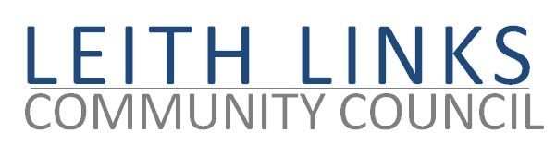

5 August 2021

Dear Veolia and Scottish Water,

On behalf of our local community, the Leith Links Community Council was shocked and deeply disturbed to read the information from SEPA concerning sewage contamination found in 5-6 samples taken in June and July around Scotland, (see attached summary) ‘endangering the health of swimmers and surfers in Dumfries and Galloway, Ayrshire, Argyll, Highland, Aberdeenshire, Fife and Lothian.’
Below is an extract relating to Portobello:
West Beach, Portobello, Edinburgh | sample breach 14 times limit 5 July, predicted poor 28, 29 July
Central Beach, Portobello, Edinburgh | sample breach 10 times limit 5 July, predicted poor 28, 29 July
The fact that these very busy and popular beaches are so badly polluted at all is shocking, even more so at this time when so many people are bathing and swimming for their physical and mental health.
That the west beach is significantly more polluted than the central beach points very strongly to the source being Seafield Waste Water Treatment Facility. This calls into extreme question the claim made by Veolia that effluent released into the Forth estuary is completely treated and effectively clean.
Although Portobello beach is just outside our own Community Council area, it is much used by local people. In any case, this information suggests a level of pollution which should be of great concern to all citizens..
In view of the serious nature of this evidence we urgently expect a response and an explanation from you, about causes and remedies, which we can share with our local communities.
Yours sincerely,
Jim Scanlon MBE
Chair, Leith Links Community Council
COPY:
SEPA
Ash Denholm MSP
Tommy Sheppard MP
Deidre Brock MP
Councillor Gordon Munro
Councillor Chas Booth
Councillor Adam McVey

